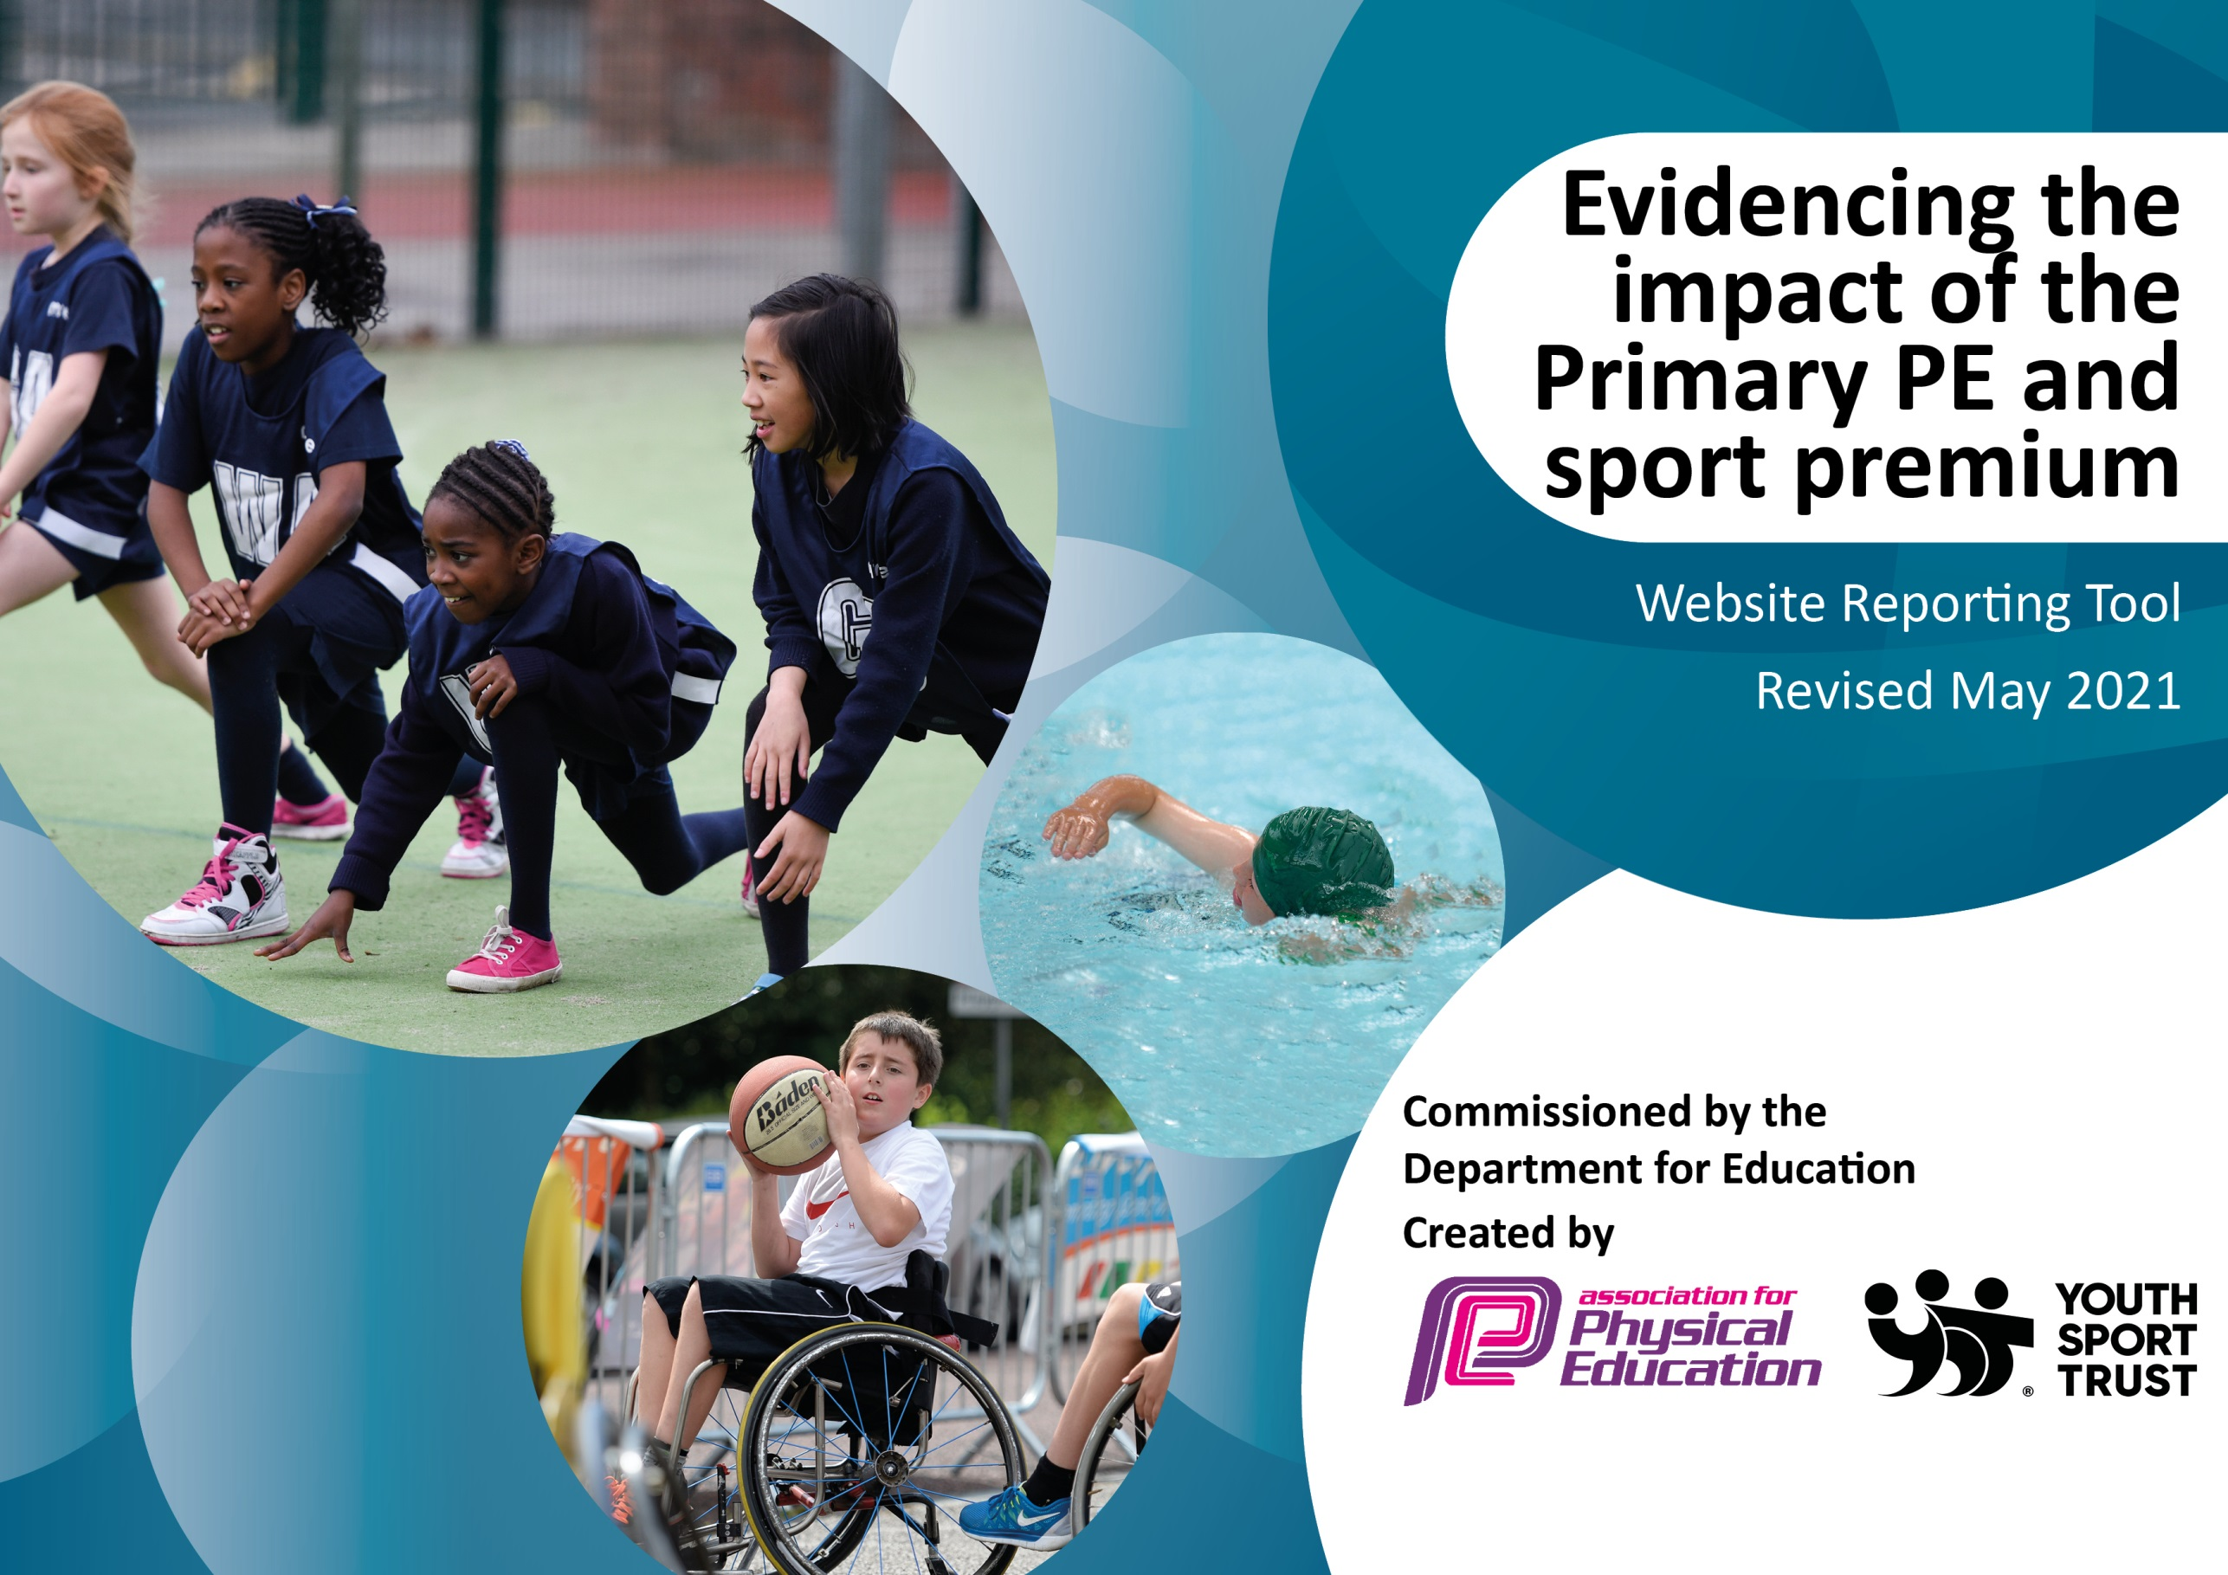

Please note: Although there has been considerable disruption in 2020-21 it is important that you publish details on your website of how you spend the funding - this is a legal requirement.
Support for review and reflection - considering the 5 key indicators from DfE, what development needs are a priority for your setting and your pupils now and why? Use the space below to reflect on previous spend and key achievements and areas for development.

N.B. In this section you should refer to any adjustments you might have made due to Covid-19 and how these will influence further improvement.
Key achievements to date until July 2022: | Areas for further improvement and baseline evidence of need:
We entered into every competitive sports competition on offer so that the children can live a normal life and return to normality post covid.  We managed to take a gymnastics team to the British Finals, where they represented Yorkshire and came 3rd in Britain.  The return of a normal school year meant that we could host our annual Sports Day. This proved to be a huge success across both sites and ran smoothly.  We entered into 4 different football leagues and the Year 3 and 4 Boys team won their league.  100% of Year 5 children have completed the Safe Travel Challenge Cup to inspire them to be more active when making their way to school.  We held our first Health week, where the children learnt about the importance of healthy bodies and healthy minds.  We held our fist community sports club, where parents were invited to take part in an after school club with their child and demonstrate being a good role model with regards to activity levels.  We introduced the children to different sports activities and hosted our first Skateboarding club and reintroduced our judo club. Due to the popularity, we will be increasing the amount of children who can take part next year.  Swimming was back up and running this year with 75% of KS2 taking part in swimming lessons again.  Both PE leads delivered training on the PE curriculum and inclusive practise to the Teamworks students and have been invited back again next year. | Due to feedback from the staff survey, next year, staff will be given CPD opportunities to support their evaluation in PE lessons.  Enhancing the cultural capital of all our pupils.  Working alongside our SIP and promoting performing arts across the PE schedule.  Continue to introduce a range of new and exciting sporting opportunities for our children.

Did you carry forward an underspend from 2021-22 academic year into the current academic year? NO * Delete as applicable
Total amount carried forward from 2020/2021 £
+ Total amount for this academic year 2021/2022 £
= Total to be spent by 31st July 2022 £ - 20,971.25
Meeting national curriculum requirements for swimming and water safety.

N.B Complete this section to your best ability. For example you might have practised safe self-rescue techniques on dry land which you can transfer to the pool when school swimming restarts.
Due to exceptional circumstances priority should be given to ensuring that pupils can perform safe self rescue even
if they do not fully meet the first two requirements of the NC programme of study.
What percentage of your current Year 6 cohort swim competently, confidently and proficiently over a distance of at least 25 metres?  N.B. Even though your pupils may swim in another year please report on their attainment on leaving primary school at the end of the summer term 2021.  Please see note above. | 40%  An additional 15% were only one grade away.
What percentage of your current Year 6 cohort use a range of strokes effectively [for example, front crawl, backstroke and breaststroke]?  Please see note above. | 40%
What percentage of your current Year 6 cohort perform safe self-rescue in different water-based situations? | 100%
Schools can choose to use the Primary PE and sport premium to provide additional provision for swimming but this must be for activity over and above the national curriculum requirements. Have you used it in this way? | Not this year, due to the swimming pool having no space/time available, due to covid catch up sessions. We have planned for this to be in place again next year.

Action Plan and Budget Tracking
Capture your intended annual spend against the 5 key indicators. Clarify the success criteria and evidence of impact that you intend to measure to evaluate for pupils today and for the future.

Academic Year: 2022/23 | Total fund allocated: | Date Updated:
Key indicator 1: The engagement of all pupils in regular physical activity – Chief Medical Officers guidelines recommend that primary school pupils undertake at least 30 minutes of physical activity a day in school |  |  |  | Percentage of total allocation:
 |  |  |  | 65.2%
Intent | Implementation |  | Impact
Your school focus should be clear what you want the pupils to know and be able to do and about  what they need to learn and to  consolidate through practice: | Make sure your actions to achieve are linked to your intentions: | Funding allocated: | Evidence of impact: what do pupils now know and what can they now do? What has changed?: | Sustainability and suggested next steps:
KS1 targeted opportunities to participate in after school clubs – an increase in % reported term on term from targeted offers.  New sports offered to those children at KS1.  A wider variety of sports available to all children at KS2 – increase % of participation and targeted increase term on term.  More opportunity to take part in daily physical activity. | Sports coach- lunchtime provision and after school clubs for all year groups. To maintain current offers and extend reach with a broader range of offers. | £13,682  (65.2%) | Autumn -  At KS1, Mr Bade has delivered 2 different Multi-sports clubs on a Wednesday evening after school. In this session, he teaches the children new skills that they can apply to different sports and gives them the opportunity to experience new sports.  34 Year 1/2 children took part in this club.  9% of these children were PP.  6% of these children were SEND.  50% of these children were girls.  50% of these children were boys.  At KS2, there have been a range of different after school clubs available for the children to take part in.  32 children have taken part in an OAA club over 2 different days, as it was so popular.  12% were SEND’  3% were PP  52% were boys  48% were girls  Mr Bade has delivered a Year 3/4 girls football club.  Year 3/4 girls football-  22 children attended.  10% were SEND.  5% were PP.  Mr Bade has delivered a Year 5/6 Basketball club.  23 children attended in total.  17% were SEND  9% were PP  Mr Bade has delivered a Year 5/6 girls rugby club.  Year5/6 Rugby club.  16 children attended.  18% were SEN  6% were PP  As well as this, he has delivered a cross country club to 45 children. 39 children qualified for the Calderdale level for this event and 28 children have qualified for the West Yorkshire level for this event.  At lunch times, Mr Bade runs multi sports clubs for all year groups. Each year group is designated a different day for their sports. Sports such as football, basketball, cricket and dodgeball have been played.
Children to be encouraged to take part in daily activity and increase their step goal each day. | Use of school Moki bands to encourage the children to be more active each day. These were purchased at the end of the last academic year and to be rolled out this year. | £0 | Autumn Term – Technical difficulties have prevented this from happening in Autumn term.  Spoken to the company to get assistance and should be in place for the Spring Term.
Key indicator 2: Raising the profile of PE and sport across the school as a tool for whole-school improvement. |  |  |  | Percentage of total allocation:
 |  |  |  | 7.46%
Intent | Implementation |  | Impact
Your school focus should be clear what you want the pupils to know and be able to do and about  what they need to learn and to  consolidate through practice: | Make sure your actions to achieve are linked to your intentions: | Funding allocated: | Evidence of impact: what do pupils now know and what can they now do? What has changed?: | Sustainability and suggested next steps:
Effective monitoring of the PE curriculum and compliance with the grant funding agreement – evaluations reported to senior leaders for approval and termly % targets identified.  Children to have increased opportunities to participate in competitive sport and non-competitive sport. % offers evaluated and targets set each term.  In-school champions for sport to support staff with the delivery of the curriculum – continuous evaluation reporting to demonstrate impact.  Areas identified in the EHNA to be targeted – evaluations link.  Children to have access to education around healthy lifestyles and mental health awareness opportunities. | Targeted staffing provision (TLR posts):  PE coordinator to ensure PE grant delivery enhances the provision for all of our children – to ensure current levels of offers are maintained and future provision adds further value. To include monitoring the effective delivery of the PE Grant Funding Plan and management our sports coach offer.  Further targeted promotions respond to the school’s outcomes from the EHNA survey.  Further promotion of mental health and well-being awareness and support opportunities across the school.  Promotion of healthy lifestyles through our link with Phunky Foods. | £1266 (6.03%) | PE team attended Calderdale Family Cluster meeting to discuss the school games programme and any other upcoming opportunities in PE and School Sport.  PE leads delivered a 3-hour training session to the Teamworks’ students about the PE curriculum, structure of a PE lesson and lesson plan ideas. Another session has been scheduled for the Spring Term.
Raising the profile of young leaders in sports by developing key leadership skills and characteristics in a fun and exciting way. | Send up to 30 children on a 6 hour Calderdale Playground/Sports Leaders Award. | £300 (1.43%) | Due to PE budget we have not been able to put this into place in the Autumn term. We will review the budget further and attempt to do this later in the year.

Key indicator 3: Increased confidence, knowledge and skills of all staff in teaching PE and sport |  |  |  | Percentage of total allocation:
 |  |  |  | 9.8%
Intent | Implementation |  | Impact
Your school focus should be clear | Make sure your actions to | Funding | Evidence of impact: what do | Sustainability and suggested
what you want the pupils to know | achieve are linked to your | allocated: | pupils now know and what | next steps:
and be able to do and about | intentions: |  | can they now do? What has
what they need to learn and to |  |  | changed?:
consolidate through practice:
Teachers will have the opportunity to observe and team teach alongside a specialist coach. They will also have the opportunity to understand how high-quality PE lessons are delivered and will understand how to make in-lesson adjustments to ensure challenge for all. | Support in PE lessons from a Sports Coach (Mr Bade) to help with confidence and the delivery of high-quality lessons both at KS1 and KS2. | £0  Already covered in a different objective | Autumn –  Teachers at KS2 are feeling more confident with their PE lessons and the teaching of OAA, with the support of Gareth. These lessons are being team taught wherever possible. Gareth has been doing different days at KS1 so more staff are able to learn and develop from him. Subject leadership observations have been completed to further support development.
Teachers will have the opportunity to observe and team teach alongside a specialist dance coach. They will also have the opportunity to understand how a series of high-quality dance lessons are planned and delivered. | Targeted contemporary Dance CPD provision – as a targeted area of need. | £2070 (9.8%) | This is starting in the Spring Term.
Following the results from the 2021/2022 staff audit, increase the knowledge and confidence of staff when delivering evaluation as part of your PE lessons. | Provide staff training and lesson ideas for all staff in the area of evaluation to increase their confidence and understanding of this area of PE. | £0 | We have purchased PE specific iPads to give more opportunities and to encourage children to evaluate their learning. Further staff training will be given in spring term to help teachers understand how this should look (on seesaw).
Key indicator 4: Broader experience of a range of sports and activities offered to all pupils |  |  |  | Percentage of total allocation:
 |  |  |  | 14.2%
Intent | Implementation |  | Impact
Your school focus should be clear | Make sure your actions to | Funding | Evidence of impact: what do | Sustainability and suggested
what you want the pupils to know | achieve are linked to your | allocated: | pupils now know and what | next steps:
and be able to do and about | intentions: |  | can they now do? What has
what they need to learn and to |  |  | changed?:
consolidate through practice:
Provide the children with the opportunity to take part in sports that are not possible to be delivered on school site.  Children will develop teamwork and communication skills.  Children in Year 5 will be prepared for their residential trip in Year 6. Evaluations to reflect the range of opportunities. | Year 5 children to visit the Boiler House for a term to participate in outdoor and adventurous activities – to enhance and extend PE activity offers. | £2503.25 (11.9%) | This will be actioned in the Summer Term.
More boys to become engaged and participate in dance.  Boys to have increased enjoyment in dance due to having a male role model.  Children have the opportunity to take part in different styles of dance.  Evaluations to specify additionally of the offer. | To offer contemporary dance in PE lessons to different year groups throughout the academic year. | Already covered in previous objective (£2070) | This is starting in the Spring Term.
Children will be able to go back to swimming lessons having missed their previous provision due to Covid. They will aim to achieve their National Curriculum Award. | Year 3, 4 and 5 to attend swimming lessons throughout the academic year in order to pass the National Curriculum Award by the end of Year 5. | £7203.30  (Money is taken from a different budget) | Autumn -  60 Year 4 children attended swimming in the Autumn Term. We targeted this year group as they’ve not been swimming with school, due to covid restrictions.  4G - September  6 non swimmers  15 with some experience in water but not full swimmers  9 weak movers (could swim but doggy paddle stroke)  4G - December  2 non swimmers  11 with some experience  6 weak movers  11 10m swimmers  4A - September  12 non swimmers  3 some experience but not full swimmers  15 weak movers  4A - December  6 non swimmers  6 some experience  9 weak movers  9 10m swimmers
Provide the children with the opportunity to take part in a wider range of sports clubs. | To provide the opportunity to Ks1 and KS2 pupils to take part in an after school skateboarding club. | £0 (Parents to pay £600) | This will be actioned later in the academic year. Parents to pay due to budget.
Provide the children with the opportunity to take part in a wider range of sports clubs. | To provide the opportunity to all pupils to take part in an after school Judo club. | £0 | This has begun in Autumn term – 22 KS2 children attend every week. Payed for by Parents.  KS2 Judo Club –  22 children attended  10% were SEND  10% were PP
In line with the school improvement plan focussing on performing arts – Raising the profile of cultural dance and allowing the children to take part in different styles of dancing. | To provide the opportunity to all pupils to take part in a “Dance around the world workshop.” | £500 (2.3%) | To be actioned later in the year.
In line with the school improvement plan focussing on performing arts – Raising the profile of Thai Chi and allowing the children to take part in different cultural sports. | To provide the opportunity to all pupils to take part in a Thai Chi after school club. | £0 | To be actioned later in the year.

Key indicator 5: Increased participation in competitive sport |  |  |  | Percentage of total allocation:
 |  |  |  | 3%
Intent | Implementation |  | Impact
Your school focus should be clear  what you want the pupils to know  and be able to do and about  what they need to learn and to  consolidate through practice: | Make sure your actions to  achieve are linked to your  intentions: | Funding  allocated: | Evidence of impact: what do pupils now know and what can they now do? What has changed? | Sustainability and suggested  next steps:
To maintain and extend;  - opportunities for children to take part in healthy competition within school.  - inter-house competitions.  - participation in external sporting events.  - opportunities for children to apply skills learnt in lessons and clubs.  Specific numbers/% reported on termly evaluations. | Sports coach to coordinate sports events both inside and outside of the school hours – to maintain previous year’s offers and further enhance with new activities. | £0  Covered in a previous objective | Autumn –  45 KS2 children took part in the Elland Cluster Cross Country Event.  8% of these children were SEND.  50% were boys.  50% were girls.  2.5% were PP children.  37 KS2 children took part in the Calderdale Cross Country Event.  10% of these children were SEND.  50% were boys.  50% were girls.  3% were PP children.  28 KS2 children have qualified for the West Yorkshire Cross Country Event.  4% of these children are SEND.  45% are boys.  55% are girls.  8 children took part in the Primary Panthalon Competition.  86% of these children were SEND.  75% were boys.  25% were girls.  0% were PP children.  8 girls took part in a Girls Tag Rugby Competition. They won the competition.  25% were SEND  0% were PP  12 children went to a Boccia Competition.  56% were SEND  16% were PP  4 children went to a Bowling competition.  100% were SEND  75% were PP  50% were boys  50% were girls  4 girls went to a Kurling event.  100% were SEND  0% were PP
Children are able to participate in competitive sports and are exposed to new competitive opportunities. | Entry to the Calderdale School Games Programme in order to enter a wide range of sporting competitions. | £400 (1.9%) | Autumn –  We have entered the Calderdale School Games Programme and have entered all of the sporting events so far this academic year.
Children are able to participate in competitive sports and are exposed to new competitive opportunities. | Entry into the Primary Dance Off for KS2 pupils. | £250 – Entry £45 (1.1%) | This will be actioned later in the academic year.

Signed off by
Principal: | Helen Crowther
Date: | 1/9/22
Subject Leader: | Chris O’Shea
Date: | 1/9/22
Governor: | Peta Coker
Date: | 1/9/22

