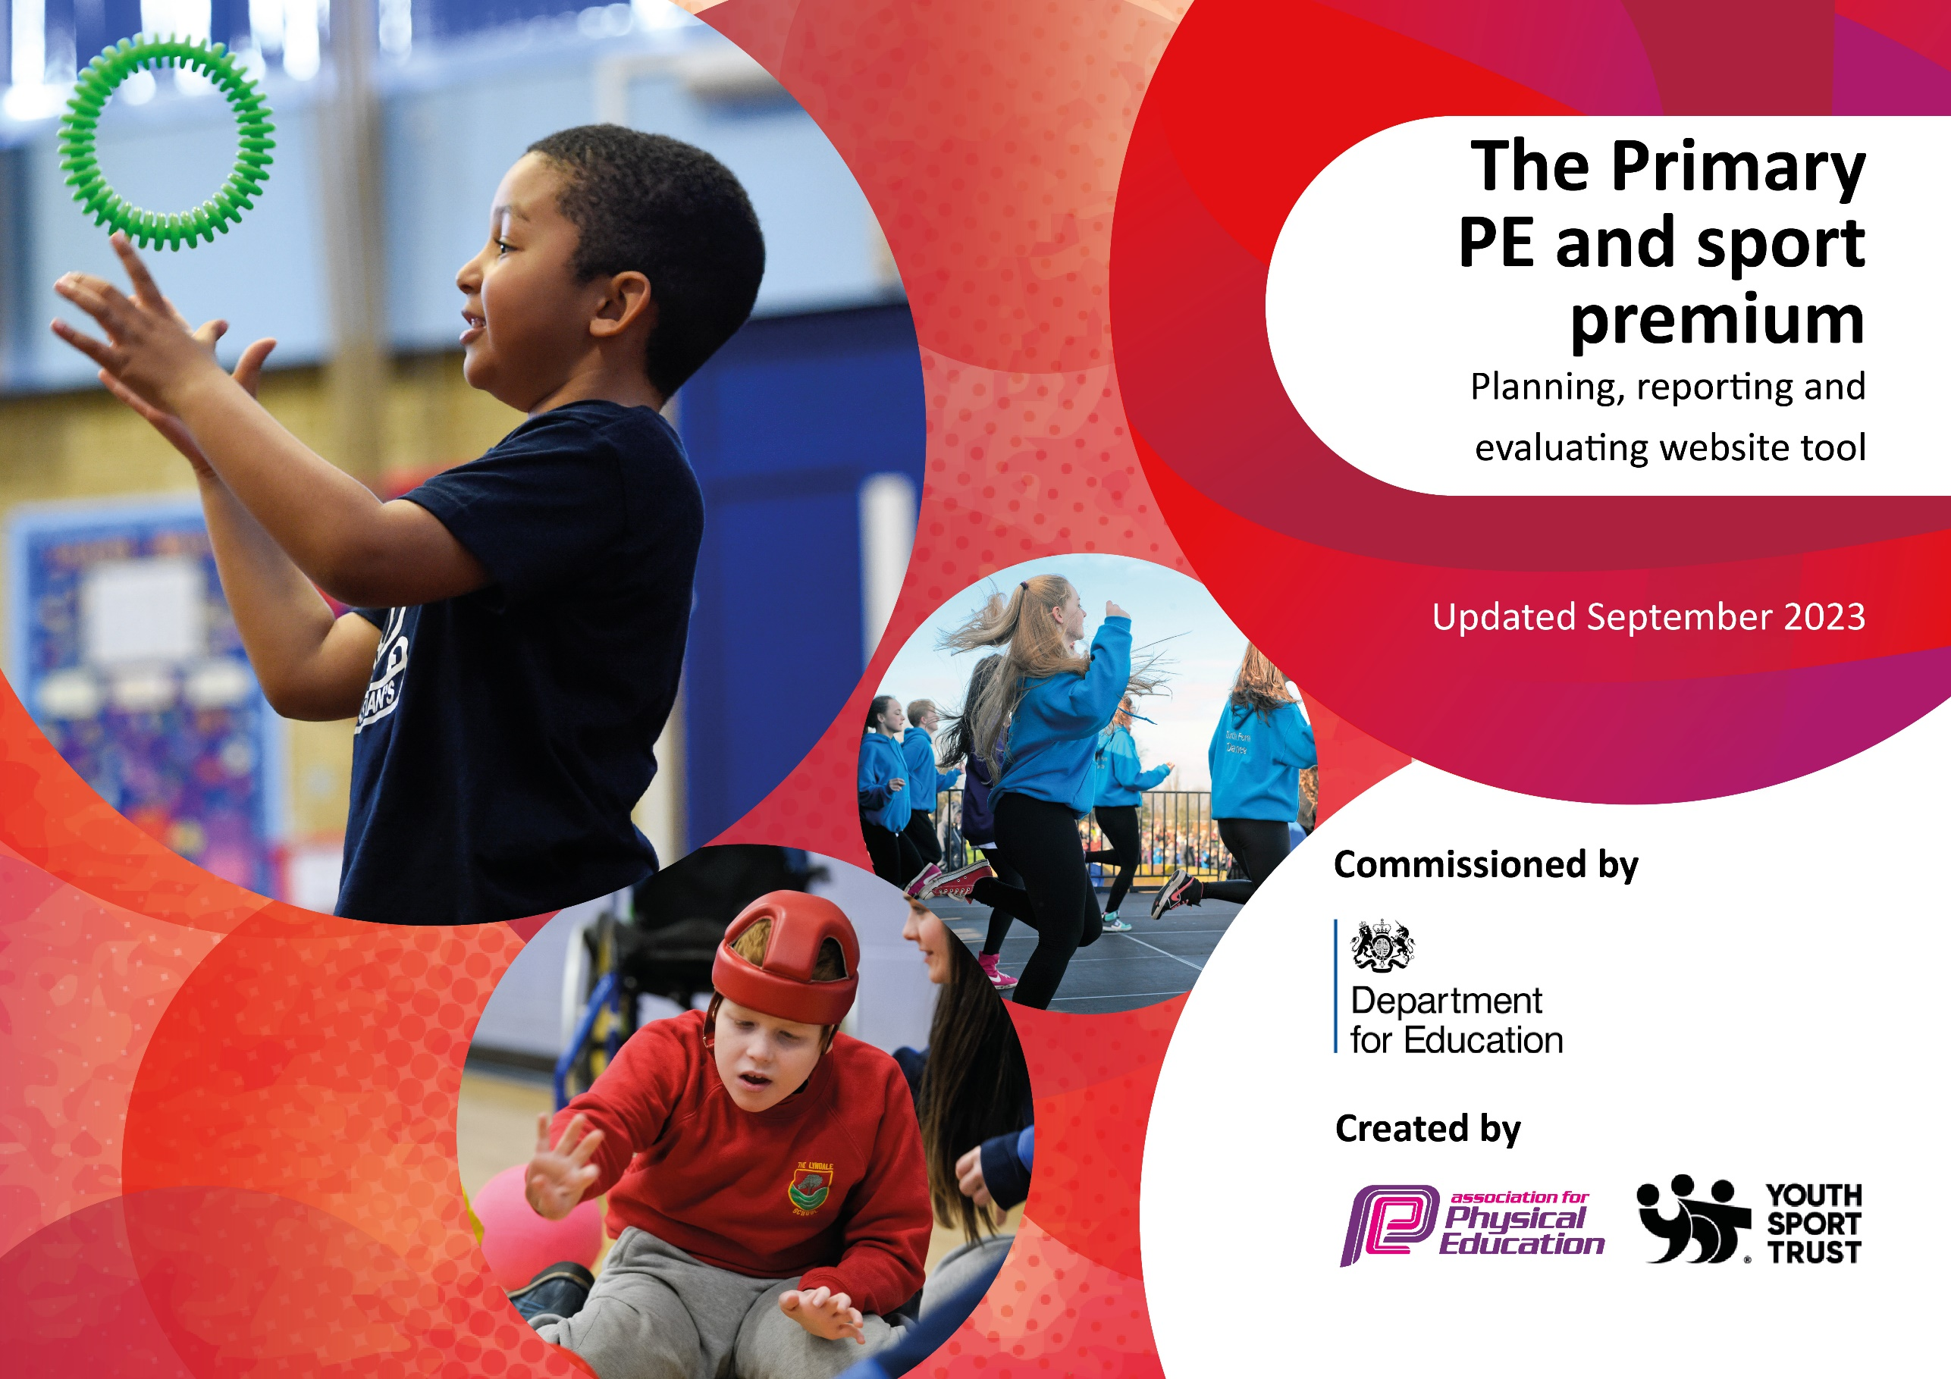

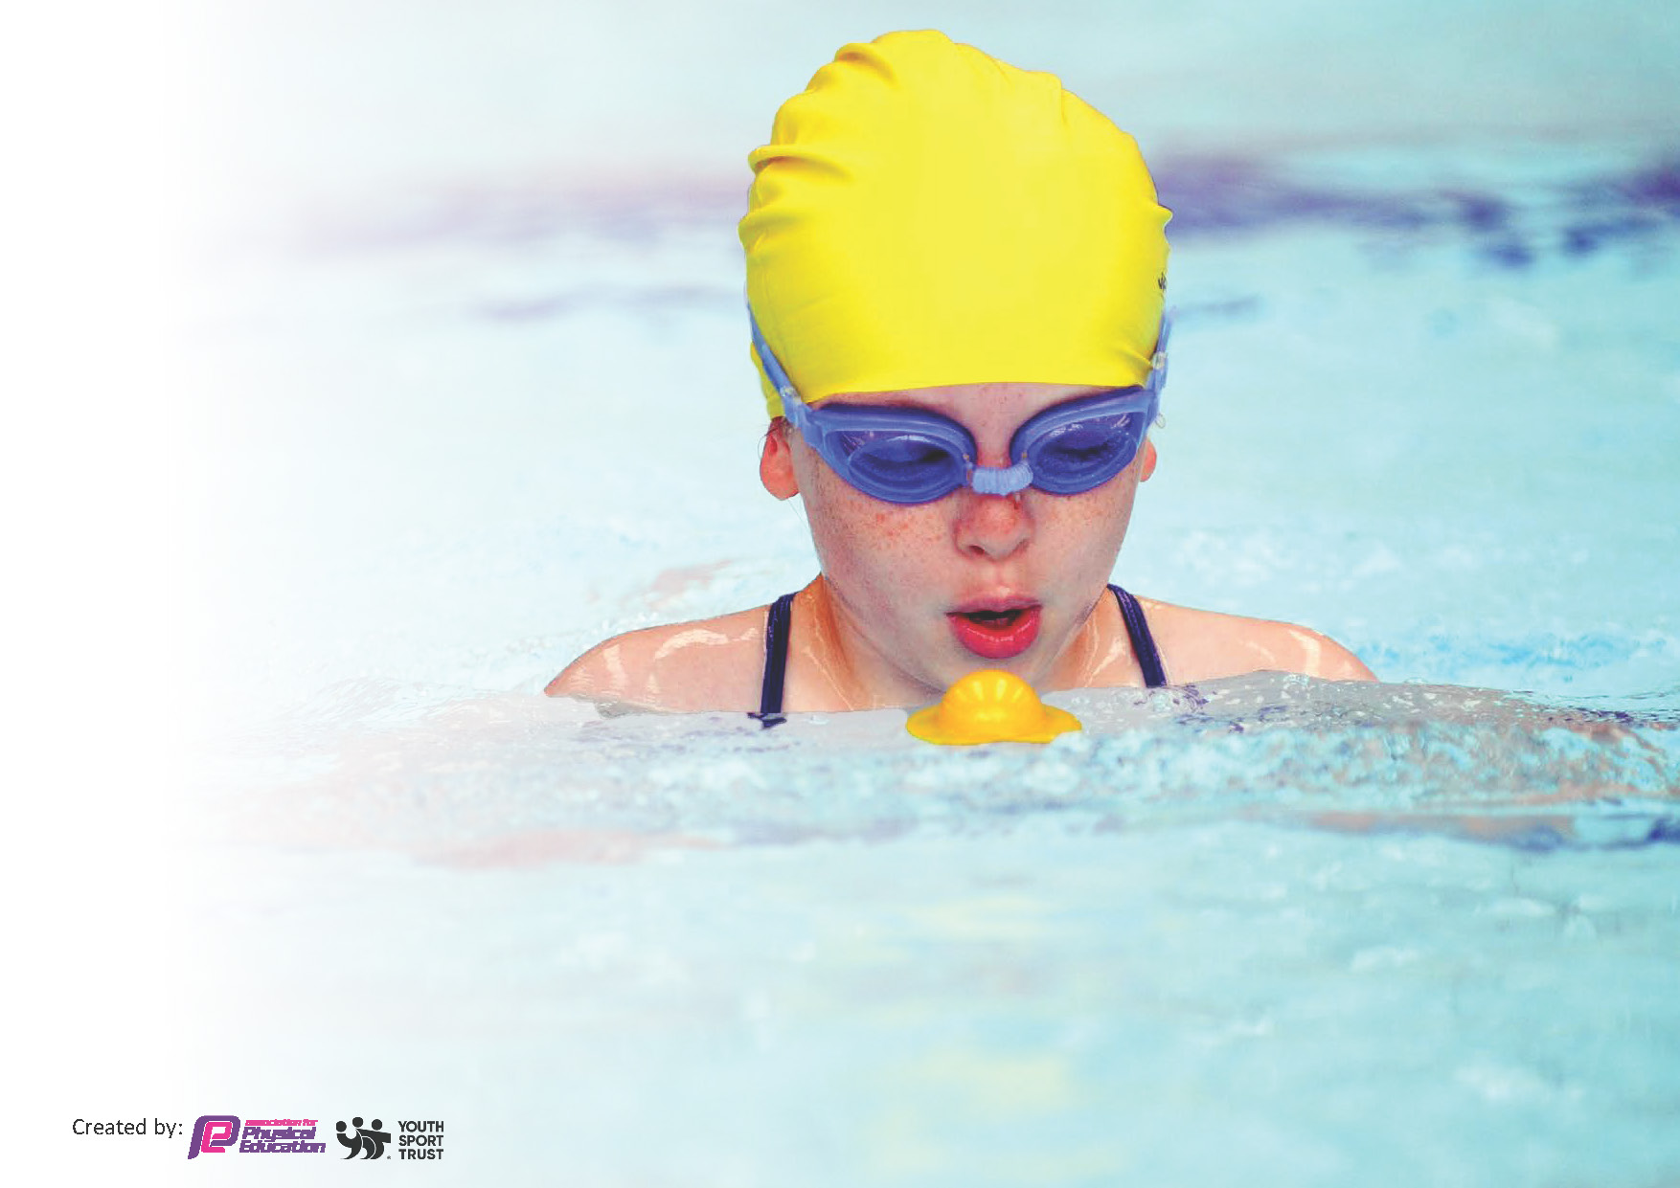
This template can be used for multiple purposes:
by:
- It enables schools to effectively plan their use of the Primary PE and sport premium
- It helps schools to meet the requirements (as set out in guidance) to publish information on their Primary PE and sport premium
- It will be an effective document to support Ofsted inspections enabling schools to evidence progress in Physical Education (PE) and evidence swimming attainment, which forms part of the PE National Curriculum. We would recommend schools consider
the Intent, Implementation and Impact of any spend, as examined within the Education Inspection Framework.

It is important that your grant is used effectively and based on school need.

Schools must use the funding to make additional and sustainable
improvements to the quality of the PE, School Sport and Physical Activity (PESSPA)
they offer. This means that you should use the Primary PE and sport premium to:

- Build capacity and capability within the school to ensure that improvements made now will benefit pupils joining the school in future years
- Develop or add to the PESSPA activities that your school already offers.

The Primary PE and sport premium should not be used to fund capital spend projects; the school’s core budget should fund these. Further detail on capital expenditure can be found in the updated Primary PE and sport premium guidance.

The Primary PE and sport premium guidance, outlines 5 key priorities that funding should be used towards. It is not

necessary that spending has to meet all the key priorities, you should select the priorities that you aim to use any funding towards.

Although completing this template is not a requirement for schools, schools are required to publish details of how they spend this funding. Schools must also outline what the impact this funding has had on pupils’ PE and sport participation and attainment and how any spending will be sustainable in the future. All funding must be spent by 31st July 2024.

The Department for Education has worked closely with the Association for Physical Education (afPE) and the Youth Sport Trust (YST) to develop this template and encourages schools to use it. This template is an effective way of meeting the reporting requirements of the Primary PE and sport premium.
Review of last year’s spend and key achievements (2022/2023)

We recommend you start by reflecting on the impact of current provision and reviewing your previous spend.

Activity/Action | Impact | Comments
We entered into every competitive sports competition on offer so that the children can live a normal life and return to normality post covid.  We managed to take a gymnastics team to the British Finals, where they represented Yorkshire.  We hosted our annual Sports Day. This proved to be a huge success across both sites and ran smoothly.  We entered into 4 different football leagues and the Year 3 and 4 Boys team won their league, as did the Year 5 and 6 Girls team.  KS2 took part in the Dance around the world project to enhance cultural capital and encourage children to dance.  We held our second Health week, where the children learnt about the importance of healthy bodies and healthy minds.  We held our second community sports club, where parents were invited to take part in an after school club with their child and demonstrate being a good role model with regards to activity levels.  We introduced the children to different sports activities and hosted our second Skateboarding club and reintroduced our judo club. Both of these will continue.  Swimming was back up and running this year with 75% of KS2 taking part in swimming lessons again.  PE lead delivered training on the PE curriculum and inclusive practice to the Teamworks students (ITT provider). | From all of the actions stated, the impact was significant. We had significantly more children participating in a range of different sports. 10% of the gymnastics team qualified for the British Finals in Stoke, competing at a higher level for the second year in a row.  Our dedication and engagement in competitive sport resulted in us achieving the Gold award for the school games mark. Again, this has been for the second year running. Our plan is to continue to achieve this standard for the coming years, in order to achieve our goal of being rewarded with the platinum award.  Our annual Health week continued to showcase and encourage how to live a healthy lifestyle for both pupils and parents. | Due to feedback from the staff survey, next year, staff will be given CPD opportunities to support their evaluation in PE lessons.  We will continue to increase the variety of sports that pupils can take part in.  We aim to ensure that the curriculum is applicable and usable for staff, particularly when they are not being supported in lessons by the sports coach.

Key priorities and Planning
This planning template will allow schools to accurately plan their spending.

Action – what are you planning to do | Who does this action impact? | Key indicator to meet | Impacts and how sustainability will be achieved? | Cost linked to the action
KS1 targeted opportunities to participate in after school clubs – an increase in % reported term on term from targeted offers.  New sports offered to those children at KS1.  A wider variety of sports available to all children at KS2 in after school clubs and lunch time clubs – increase % of participation and targeted increase term on term.  More opportunity to take part in daily physical activity. | Lunchtime supervisors / teaching staff - as they need to be mentored by the sports coach, in order to learn how to provide this provision themselves in the future  pupils – as they will take part | Key Indicator 1: Increased confidence, knowledge, and skills of all staff in teaching PE and sport.  Key indicator 2: The engagement of all pupils in regular physical activity – the Chief Medical Officer guidelines recommend that all children and young people aged 5 to 18 engage in at least 60 minutes of physical activity per day, of which 30 minutes should be in school.  Key indicator 3: Raising the profile of PE and sport across the school.  Key indicator 4: Broader experience of a range of sports and activities offered to all pupils. | More pupils meeting their daily physical activity goal, more pupils encouraged to take part in PE and Sport Activities.  Staff to gain CPD through being mentored during these sessions. | £15,464 (79.26%) - costs for sports mentor/coach to support lunchtime sessions , staff CPD and after school clubs.
CPD for teachers on how to deliver and evaluate effective PE lessons and sports clubs. | Primary generalist teachers. | Key Indicator 1: Increased confidence, knowledge, and skills of all staff in teaching PE and sport.  Key indicator 5: Increased participation in competitive sport. | Primary teachers more confident to deliver effective PE supporting pupils to undertake extra activities inside and outside of school. | Budget stated above as CPD will come through sports mentor/coach

Children encouraged to take part in daily exercise and be active during break and lunch times. | pupils – as they will use the equipment to take part in daily activity and raise the profile of healthy living | Key indicator 2: The engagement of all pupils in regular physical activity – the Chief Medical Officer guidelines recommend that all children and young people aged 5 to 18 engage in at least 60 minutes of physical activity per day, of which 30 minutes should be in school.  Key indicator 4: Broader experience of a range of sports and activities offered to all pupils. | Provide a range of new equipment to support both play at break and lunch time and also to ensure that PE lessons are as effective as they can be. | £500 for new equipment
Raising the profile of young leaders in sports by developing key leadership skills and characteristics in a fun and exciting way. | Sports ambassadors – as they will undergo the training  All pupils will benefit from play leaders being present | Key indicator 2: The engagement of all pupils in regular physical activity – the Chief Medical Officer guidelines recommend that all children and young people aged 5 to 18 engage in at least 60 minutes of physical activity per day, of which 30 minutes should be in school.  Key indicator 3: Raising the profile of PE and sport across the school. | Send up to 12 children on a 6 hour Calderdale Playground/Sports Leaders Award. | £0 – Training delivered for free by the school games mark team
Teachers will have the opportunity to observe and team teach alongside a specialist mentor. They will also have the opportunity to develop an understanding of how high-quality PE lessons are delivered and will understand how to make in-lesson adjustments to ensure challenge for all. | Staff – as they will be mentored by the sports coach | Key Indicator 1: Increased confidence, knowledge, and skills of all staff in teaching PE and sport.  Key indicator 3: Raising the profile of PE and sport across the school.  Key indicator 4: Broader experience of a range of sports and activities offered to all pupils. | Professional development and mentoring in PE lessons and clubs from a Sports Coach (Mr Bade) to help with confidence and the delivery of high-quality lessons both at KS1 and KS2. | Covered in the sports mentor budget above
Teachers will have the opportunity to observe and team teach alongside a specialist dance coach. They will also have the opportunity to understand how a series of high-quality dance lessons are planned and delivered.  More boys to become engaged and participate in dance.  Boys to have increased enjoyment in dance due to having a male role model.  Children have the opportunity to take part in different styles of dance.  Evaluations to specify additionally of the offer. | Staff – as they will develop their CPD through working with a professional | Key Indicator 1: Increased confidence, knowledge, and skills of all staff in teaching PE and sport.  Key indicator 2: The engagement of all pupils in regular physical activity – the Chief Medical Officer guidelines recommend that all children and young people aged 5 to 18 engage in at least 60 minutes of physical activity per day, of which 30 minutes should be in school.  Key indicator 3: Raising the profile of PE and sport across the school.  Key indicator 4: Broader experience of a range of sports and activities offered to all pupils. | Targeted contemporary Dance CPD provision – as a targeted area of need. | £720
Provide the children with the opportunity to take part in a wider range of sports clubs. | pupils – as they will take part | Key indicator 2: The engagement of all pupils in regular physical activity – the Chief Medical Officer guidelines recommend that all children and young people aged 5 to 18 engage in at least 60 minutes of physical activity per day, of which 30 minutes should be in school.  Key indicator 3: Raising the profile of PE and sport across the school.  Key indicator 4: Broader experience of a range of sports and activities offered to all pupils. | To provide the opportunity to lower KS2 and upper KS2 pupils to take part in an after school skateboarding, judo, cycling, dancing from around the world, fitness and Zumba/yoga club. | £1650
Ensure that the children are aware of the importance of a healthy lifestyle and how to achieve this. | Staff, children and parents as we will all take part in activities and learn more about healthy lifestyles | Key indicator 2: The engagement of all pupils in regular physical activity – the Chief Medical Officer guidelines recommend that all children and young people aged 5 to 18 engage in at least 60 minutes of physical activity per day, of which 30 minutes should be in school.  Key indicator 3: Raising the profile of PE and sport across the school. | Health week | £500
To maintain and extend;  - opportunities for children to take part in healthy competition within school.  - inter-house competitions.  - participation in external sporting events.  - opportunities for children to apply skills learnt in lessons and clubs.  Specific numbers/% reported on termly evaluations.  Children are able to participate in competitive sports and are exposed to new competitive opportunities.  Children are able to participate in competitive sports and are exposed to new competitive opportunities.  Children are able to participate in competitive sports and are exposed to new competitive opportunities. | PE coordinators will develop their CPD through being mentored by sports coach.  pupils – as they will take part  pupils – as they will take part  Pupils – as they will take part  Pupils – as they will take part | Key Indicator 1: Increased confidence, knowledge, and skills of all staff in teaching PE and sport.  Key indicator 2: The engagement of all pupils in regular physical activity – the Chief Medical Officer guidelines recommend that all children and young people aged 5 to 18 engage in at least 60 minutes of physical activity per day, of which 30 minutes should be in school.  Key indicator 3: Raising the profile of PE and sport across the school.  Key indicator 4: Broader experience of a range of sports and activities offered to all pupils.  Key indicator 5: Increased participation in competitive sport.  Key indicator 4: Broader experience of a range of sports and activities offered to all pupils.  Key indicator 5: Increased participation in competitive sport.  Key indicator 4: Broader experience of a range of sports and activities offered to all pupils.  Key indicator 5: Increased participation in competitive sport.  Key indicator 2: The engagement of all pupils in regular physical activity – the Chief Medical Officer guidelines recommend that all children and young people aged 5 to 18 engage in at least 60 minutes of physical activity per day, of which 30 minutes should be in school.  Key indicator 4: Broader experience of a range of sports and activities offered to all pupils.  Key indicator 5: Increased participation in competitive sport. | Sports mentor to coordinate sports events alongside PE coordinators both inside and outside of the school hours – to maintain previous year’s offers and further enhance with new activities.  Entry to the Calderdale School Games Programme in order to enter a wide range of sporting competitions.  Entry to the Sports Academies Schools and Projects Programme in order to enter a wide range of sporting competitions.  Entry into the Primary Dance Off for KS2 pupils. | Covered in a previous budget  £0  £500  £50

Key achievements 2023-2024
This template will be completed at the end of the academic year and will showcase the key achievements schools have made with their Primary PE and sport premium spending.

Activity/Action | Impact | Comments

Swimming Data
Meeting National Curriculum requirements for swimming and water safety.
Priority should always be given to ensuring that pupils can perform safe self-rescue even if they do not fully meet the first two requirements of the National Curriculum programme of study

Question | Stats: | Further context  Relative to local challenges
What percentage of your current Year 6 cohort can swim competently, confidently and proficiently over a distance of at least 25 metres?
What percentage of your current Year 6 cohort can use a range of strokes effectively [for example, front crawl, backstroke, and breaststroke]?

What percentage of your current Year 6 cohort are able to perform safe self-rescue in different water-based situations? | 100%
If your schools swimming data is below national expectation, you can choose to use the Primary PE and sport premium to provide additional top-up sessions for those pupils that did not meet National Curriculum  requirements after the completion of core lessons. Have you done this? | Yes/No
Have you provided CPD to improve the knowledge and confidence of staff to be able to teach swimming and water safety? | Yes/No

Signed off by:

Head Teacher: | Helen Crowther
Subject Leader or the individual responsible for the Primary PE and sport premium: | Sarah Walsh and Chris O’Shea – PE Coordinators
Governor: | Holly Ashton
Date: | 21/9/23

