The Greetland Academy
School Uniform
& Dress Code

Dear Parent/Carer,
We appreciate that children take a lot of pride in wearing their school uniform and being a representative of The Greetland Academy. One of our core values is ‘unity’ and our school uniform is one of the ways that we show that we are all united.
This leaflet is designed to alleviate any misconceptions about what is acceptable dress code at The Greetland Academy. Appearance is not just about wearing uniform but also relates to hairstyles, nails etc. Please read this guidance carefully to avoid any dress code issues. If you have any queries please do not hesitate to contact school.
Thank you for your support in maintaining our high standards across all aspects of school life.

Kind regards,

Mrs H Crowther
Principal

UNIFORM PURCHASE – Our uniform suppliers are -
Shaw Hardcastle, 20 Commercial Street, Halifax HX1 1TB
Tel 01422 353929
https://smartschoolwearcentre.co.uk/

Other stockists are Uniform Shop, Union Street, YMCA Halifax and most supermarkets for unbranded items.
SCHOOL UNIFORM
Trousers plain, grey school trousers
Skirts plain, grey school skirts
Summer plain grey shorts or red check
summer dresses
Polo shirt white, either with school logo or plain
Sweatshirt red, either with school logo or plain
or Cardigan
Socks/Tights plain please
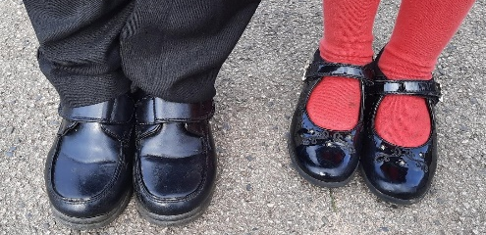
Footwear should be plain, black school-type shoes. No stripes, coloured flashes or heels.
No trainers. Boots may only be worn to travel to school and then shoes worn for the day.

Jewellery and watches are not permitted, apart from stud earrings. Children must be able to tape up or remove their own earrings for PE for health and safety reasons.

Make-up it is not necessary for children to wear make-up.
Hair hairstyles must not be extreme and only natural hair colours are permissible.

P.E.
Red Polo Shirt (ideally with The Greetland Academy logo)
Red or Black Shorts (either with school logo or plain)
Plain black joggers or leggings
Optional PE hoodie (school sweatshirts can be worn as an alternative)
PE pumps or sports trainers
PE kit will be worn to school on your child’s PE days.

